**OUT BOUND DIALER (OBD)**

**Features of service:**

Control Panel: Web Based

Integration: Https URL Base Campaign Management

Reports: Real Time Web-based & API based

**Outbound Dialing (OBD)**

Outbound Dialing (OBD) is a robust system designed to effectively manage automated bulk outbound dialling without any Capex Cost.

The system had option of

* Instantly Dial-out

Or

* Schedule dial-out to a list of mobile users uploaded by the customer as per his requirement.

It an effective tool which any Enterprise requires for its various activities like subscription reminders, alerting to subscriptions, Product Launch etc. Thereby adding immense value over manual operation of such activities on large numbers Database.

Reports can be generated on the Basis of call status.

**Key Features**

OBD-Outbound Dialer is an automated dialing system that generates simultaneous voice calls to a list of pre identified phone numbers of a target group.

OBD is a powerful, cost-effective Tele-marketing Communication service to promote various programs, advertisements, offers and value-added services to customers with reduced cost and time.

OBD provides reach to more than thousands of target customers in diversified languages.

**How it Works**

**OBD Types**

A) Promotional B) Transactional C) Transactional with DND

1. **Promotional :-** In promotional type, Call send from 0744 CLI number and DND data has been filter ( which means call not send to the DND numbers)
2. **Transactional: -** In Transactional type, call send from 0744 CLI number and DND data has been not filter in it.

**Login with the panel details with the shared login** **URL:-**

**User name: - xyz**

**Password: - 1234**

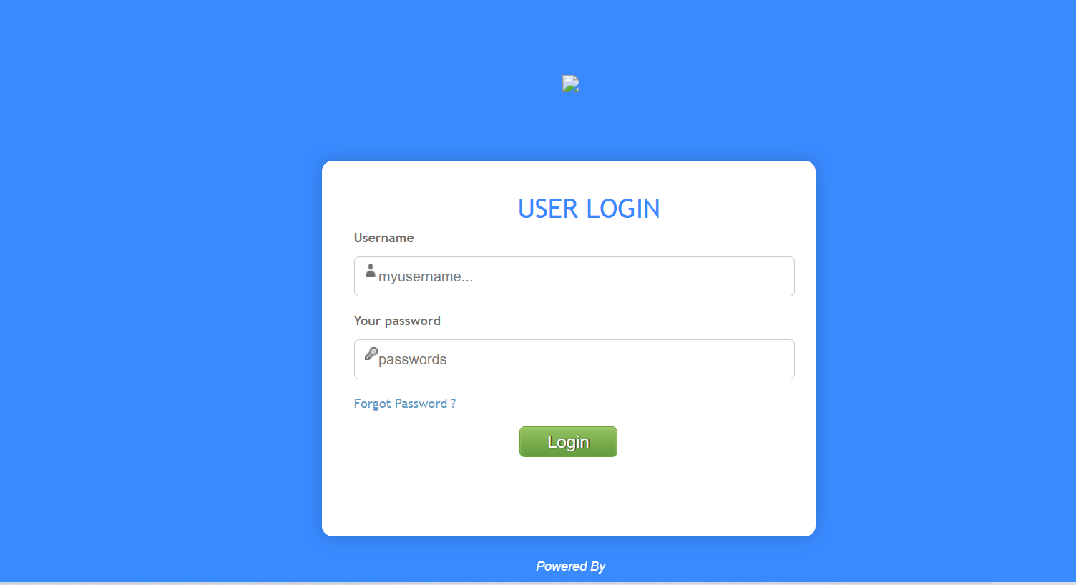

**Dashboard Detail: - Screen shot**

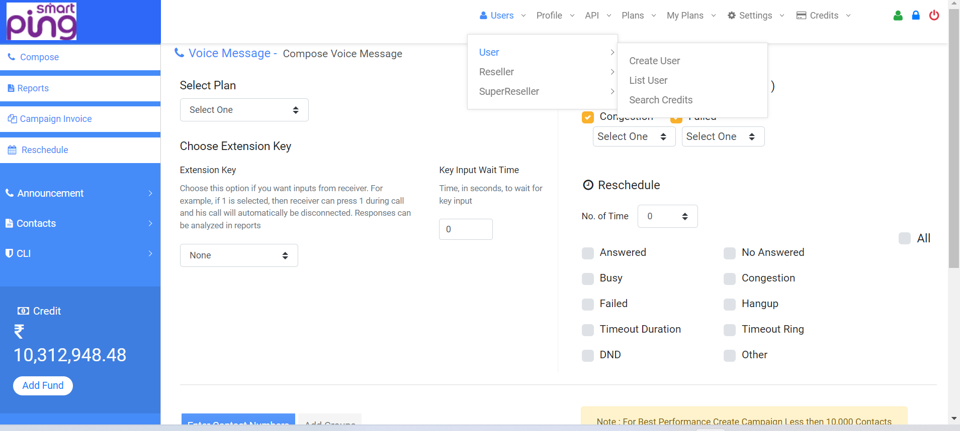

* **Users :** User can see and create user from the users
* **Profile:-** User can see their user profile
* **API: -** All API’s are available on customer panel.
* **Credits:**- User can create plan and add and deduct balance from the credit and see their recharge history
* **My Plan:-** User can see their Plan according to pulse provided.

**Option under OBD Interface**

1. GUI

**GUI:** Graphical user interface where user login to system with valid login Credentials and operate OBD interface.

B) Https based Web Service

**API:** API stands for Application Programming Interface. We have json based api. It works on POST method. User can integrate his application with our API to automate his processes. User name password will be same as used in GUI.

**Client Dashboard with it’ A/c Details **

**Various OBD Campaign Modules:-**

1. **Action required for Campaign Creation(Compose) :** Need to capture and Upload the details as mention below against the Log-in account
   * Plan selection.
   * Mention Retry count if required
   * Retry Interval—applicable in case of Retry
   * Voice file selection
   * OBD type—
     1. Simple Voice Campaign
     2. OBD with DTMF
   * OBD Campaign Type :-
     + Current
     + Scheduled

* Upload Dial-out Number’s Base(CSV format)

Activity completed for campaign execution

NOTE: - All fields are mandatory

1. **Report:** - Admin can view & fetch the live campaign report of both user reseller panel
2. **Campaign invoices: -** admin can view the users and reseller’s campaign deduction and refund from the campaign invoices.
3. **Voice File (Announcement)**:
   * User will upload voice file on the GUI portal.
   * Format of the Voice file .mp3
   * No approval required in this panel user can easily upload the voice and run their campaign
4. **Contacts :**- User can create the group and upload the data base in that group easily and the group file will reflect in compose at the time of campaign creation (Data upload limit 1lac data at a time)

**In a case, Customer requirement for redirecting the panel with domain, Then we will share the IP based URL to the customer.**

**---------------------------------------------------------------------------------------------------------------------------------------**